

**Location: 2450 N. Lake Ave., Suite B, Altadena, California**

**web-site:** [**www.randyjuradoertll.com**](http://www.randyjuradoertll.com)

**Hope you can join us! – to rsvp please e-mail: randyertll@yahoo.com**

**Book Signing at Webster’s Fine Stationers - Thursday, January 17, 2013 at 6:00 p.m.**

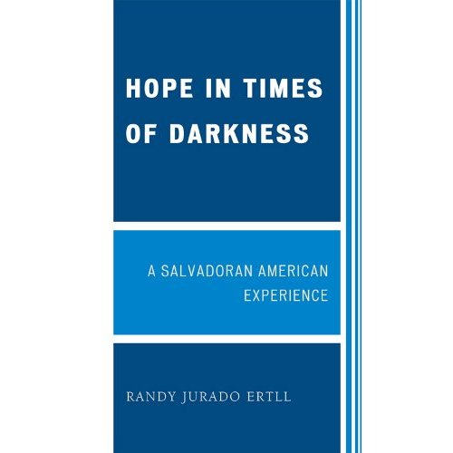

**"A heart-felt and heart-warming story while it is one man's story, it is also the story of so many who build new lives with perseverance, determination, and compassion."—Henrik Rehbinder, editorial page editor of La Opinion**

Hope in Times of Darkness sends a message that we can be agents of positive change, and that minority youth in impoverished areas can succeed in life and become productive citizens of our society. The author, a Salvadoran American, lived in El Salvador as a child but grew up in South Central Los Angeles during the late 1970s and 1980s. He observed the dynamics and challenges of the Salvadoran community. As he has both lived and transcended these struggles himself, he is able to depict a realistic and compassionate picture of the Salvadoran American/Latino experience throughout this book.

**Randy Jurado Ertll** is the executive director of El Centro de Accion Social in Pasadena, CA. He has worked for Congresswoman Hilda Solis in Washington, D.C., published numerous opinion columns in newspapers such as the Los Angeles Times and the Houston Chronicle, and has been interviewed by networks such as NPR, CNN, PBS, Univision, and Telemundo.

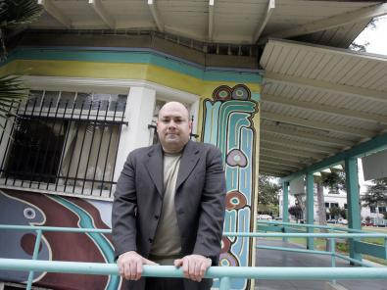

**Randy Jurado Ertll, author of *Hope in Times of Darkness:***

***A Salvadoran American Experience***